NAAN MUDHALVAN ARTS INTERNSHIP PROGRAM 2026

Frontend Web Development using React Project Submission Template

STUDENT NAME : DIVYA BHARATHI R
YEAR : 2024-2027
COLLEGE CODE : 0104
COLLEGE NAME : S.I.V.E.T. COLLEGE
DEPARTMENT : B.Sc Computer Science with Artificial Intelligence
SEMESTER : 4
ROLL NO : 222400566
NMID : 686BD608F7855CF8DB44772DF7910008
DATE : 24.06.2026
TITTLE : College Assignment Submission Tracker

1.ABSTRACT

The College Assignment Submission Tracker is a web application developed to help faculty members track student assignment submissions efficiently. The system allows users to add assignments, manage submission status, filter assignments by subject, and view a dashboard summary. The application improves organization and reduces manual tracking efforts.

2.PROBLEM STATEMENT
Many college departments face difficulties in tracking assignment submissions across multiple subjects. Manual record-keeping can lead to errors, missed deadlines, and inefficient monitoring. A digital system is needed to simplify assignment management and provide real-time tracking.

3.OBJECTIVES
- Create a user-friendly assignment tracking system.
- Add and manage assignments.
- Track submission status.
- Filter assignments by subject.
- Display dashboard statistics.
- Improve efficiency in assignment monitoring.

4.PROJECT SCOPE
Included Features
- Add Assignment
- View Assignment List
- Mark Status (Submitted, Pending, Late)
- Filter by Subject
- Dashboard Summary

Future Enhancements

Student Login System

Database Integration

Email Notifications

Assignment File Upload

5.TECHNOLOGIES USED

HTML

CSS3

JavaScript

Visual Studio Code

Google Chrome

6.APPLICATION FLOW

- User opens the application.
- User enters assignment details.
- Assignment is added to the system.
- User selects submission status.
- Dashboard updates automatically.
- User filters assignments by subject.
- System displays matching assignments

7.KEY REACT CONCEPTS USED
This project was developed using HTML, CSS, and JavaScript, React concepts were not implemented. Future versions can use:
- Components
- State Management
- Props
- Event Handling
- Conditional Rendering

8.EXPECTED OUTPUT
The application displays:
- Total Assignments Count
- Submitted Assignments Count
- Pending Assignments Count
- Late Assignments Count
- Assignment Details Table
- Subject Filtering Option

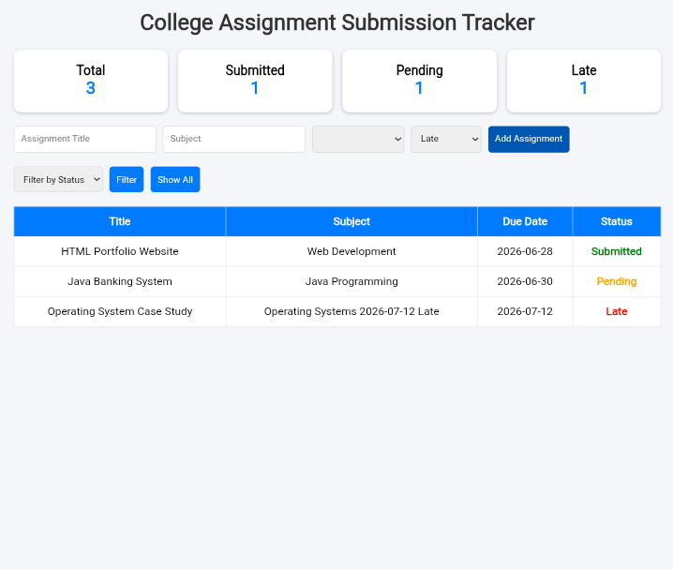

9.CHALLENGES FACED
- Designing a responsive dashboard.
- Managing assignment status updates.
- Implementing subject filtering.
- Ensuring a user-friendly interface.

10.LEARNING OUTCOMES
- Learned HTML page structure.
- Improved CSS styling skills.
- Implemented JavaScript DOM manipulation.
- Developed dashboard-based applications.
- Improved problem-solving and debugging skills.

11.CONCLUSION
The College Assignment Submission Tracker was successfully developed to simplify assignment management in educational institutions. The system provides an efficient way to monitor submissions, track assignment status, and generate dashboard summaries. The project achieved all planned objectives and enhanced practical web development skills.
Github link: https://github.com/divyabharathirsivetai-cyber/College-assignment-submission-tracker.git
Output link: https://divyabharathirsivetai-cyber.github.io/College-assignment-submission-tracker/

